

|  |  |
| --- | --- |
| **Version Number** | **2** |
| **Approved** | **18/9/23 by the Trustee Board** |
| **Next Review** | **August 2026** |

**Incidents and Illness Policy** **and Procedures**

Leaders follow The [Scout Association guidelines](https://www.scouts.org.uk/volunteers/staying-safe-and-safeguarding/incidents-and-illness/) concerning incidents and illness. Leaders complete basic first aid training and will administer first aid to the best of their ability. Medical assistance will be sought if appropriate.

The persons responsible for first aid assessment are: **Section Leaders**

First Aid Kit

First aid kits are available at Nyamba and portable kits are available for outings and camps.

Consent Forms

Parents / guardians will complete the relevant section of OSM authorising leaders to administer medicines / emergency first aid.

Reporting and Recording Incidents and Illness

Incidents and illness which occur should be recorded (including incidents and illness which occur when travelling to / from a scouting activity).

Only brief details of any treatment given is maintained; a confidential record is made in the ‘Accident’ Book as soon as possible to minimise the possibility of information and details being forgotten. Parents and the Group Scout Leader (GSL) will be notified. The record is then removed from the Accident Book to maintain confidentiality and stored securely by the GSL.

In certain circumstances, the GSL or Chair of the Trustee Board, will make a report to the Scout Association Headquarters or HSE (Health & Safety Executive).

**First Aid & Accidents**

**Additional guidance for Leaders**

First Aid Kits

First Aid kits are in place at Nyamba in the kitchen, by the downstairs stores and portable ones available for outings and camps - to be kept (and RETURNED) in the steel cupboard in main stores.

Guidance on Recording Accidents

The Accident Reporting Book is kept in the first aid kit in the kitchen and in the health and safety folder in the stairwell.

One page should be completed per accident - the information is straightforward and there are prompts to guide you.

If the accident occurs at a camp or outing, the page should be completed as soon as you can when you return.

Inform parents / carers but there is no need to give them a copy of the page as this is for our records.

After completing, please remove the page (to comply with the Data Protection Act) and hand to the GSL at the earliest opportunity.

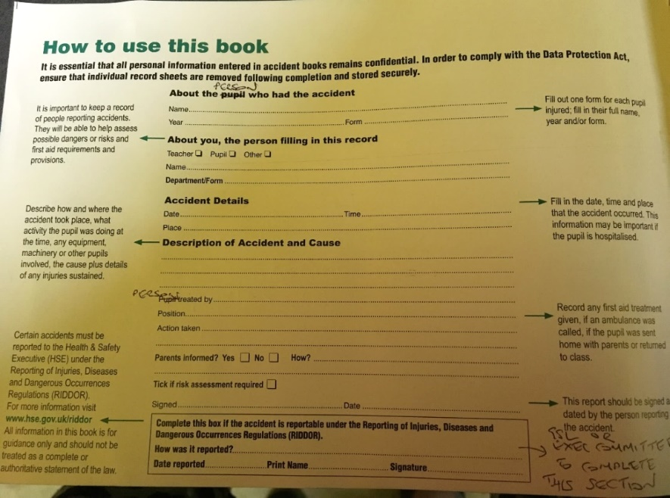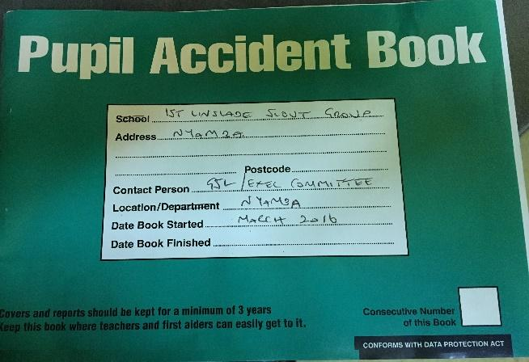

Photographs

If it is necessary to photograph any injuries / accident / incident then photographs, digital or otherwise MUST be kept confidential until reviewed by the GSL. . On no account should they be shared on social media / email / text. All Adults, Occasional Helpers (and anyone else present), should be asked not to take photographs in these circumstances unless requested to do so by the Leader in charge.

More guidance

Scout Association Incidents and Illness [HERE.](https://www.scouts.org.uk/volunteers/staying-safe-and-safeguarding/incidents-and-illness/)

‘The Yellow Card’ (Young People First) can be down loaded [HERE.](https://www.scouts.org.uk/volunteers/staying-safe-and-safeguarding/safe-scouting-cards/young-people-first-yellow-card/)

‘The Purple Card’ (Safe Scouting and what to do in an emergency) which can be down loaded [HERE.](https://www.scouts.org.uk/volunteers/staying-safe-and-safeguarding/safe-scouting-cards/safe-scouting-and-emergency-procedures/)